River Valley Charter School

Mickey Mouse Bot

This is our Mickey Mouse bot.

Basically, it is the demobot with an arm (effector) that has a box to hold the gold poms.

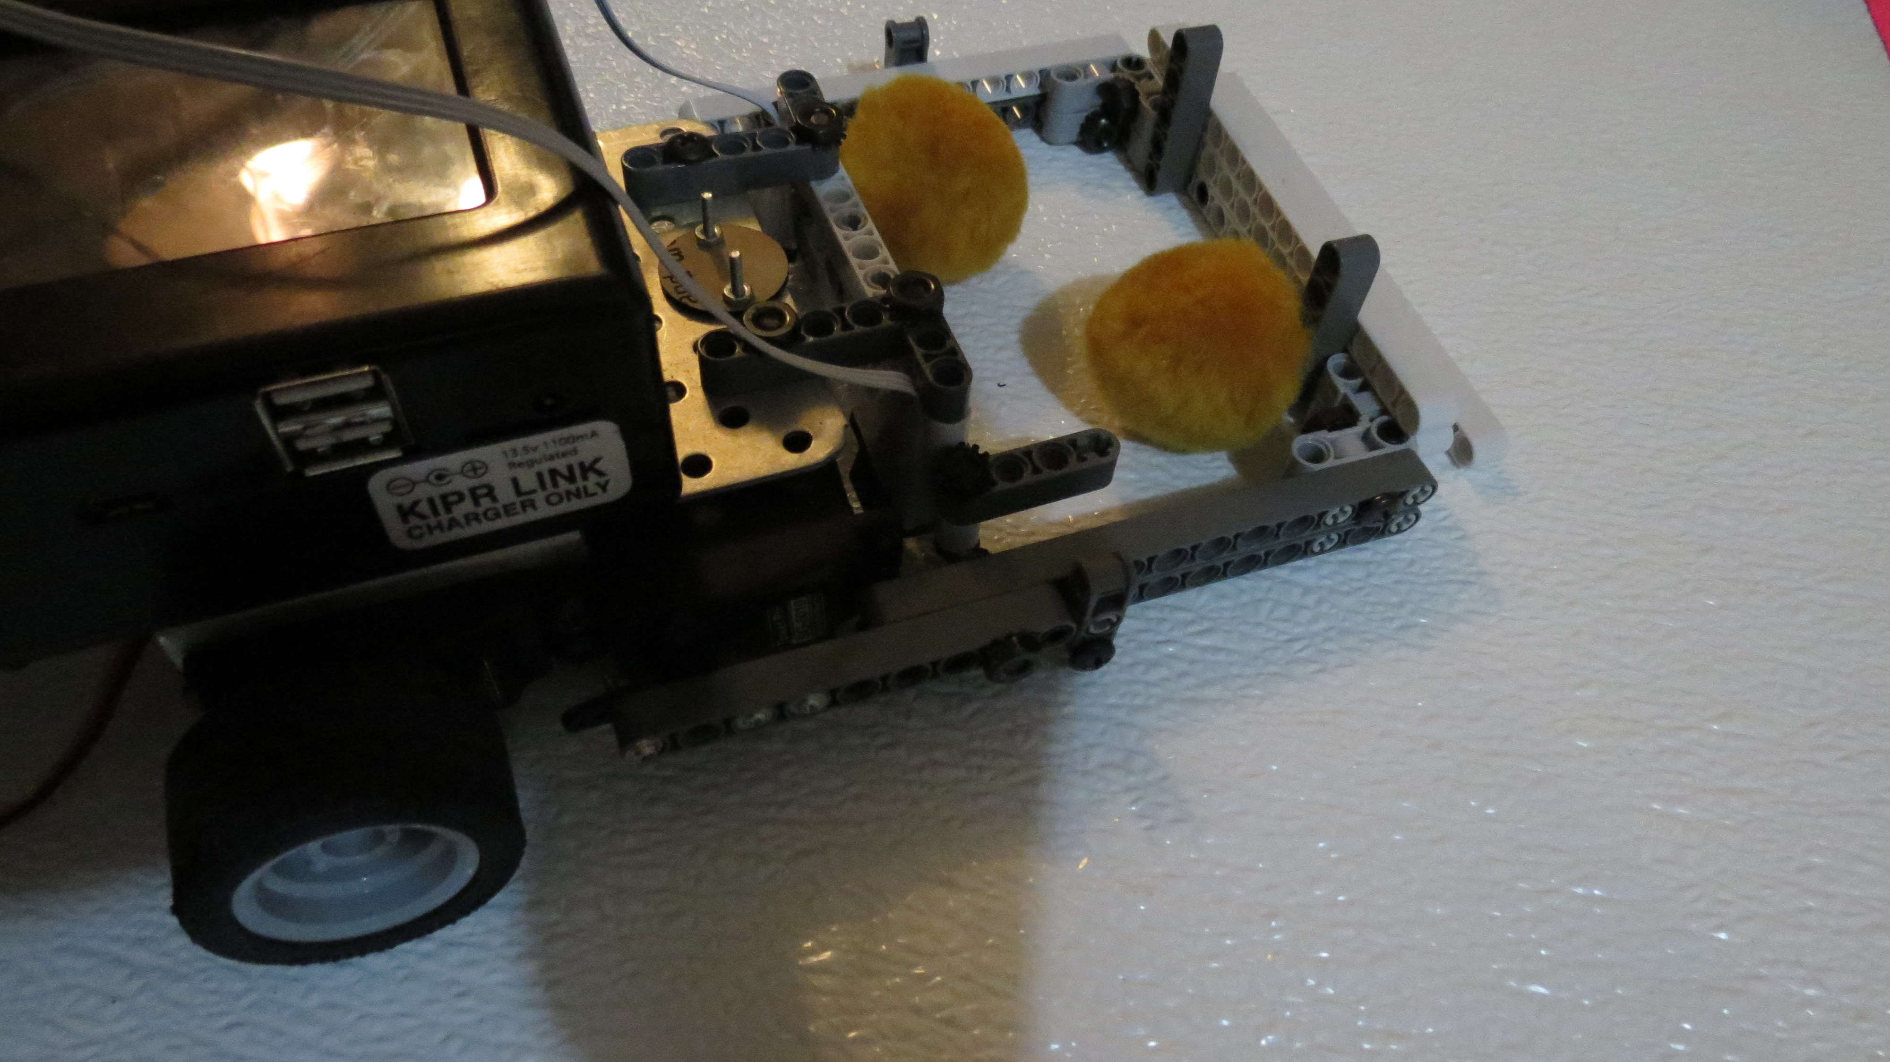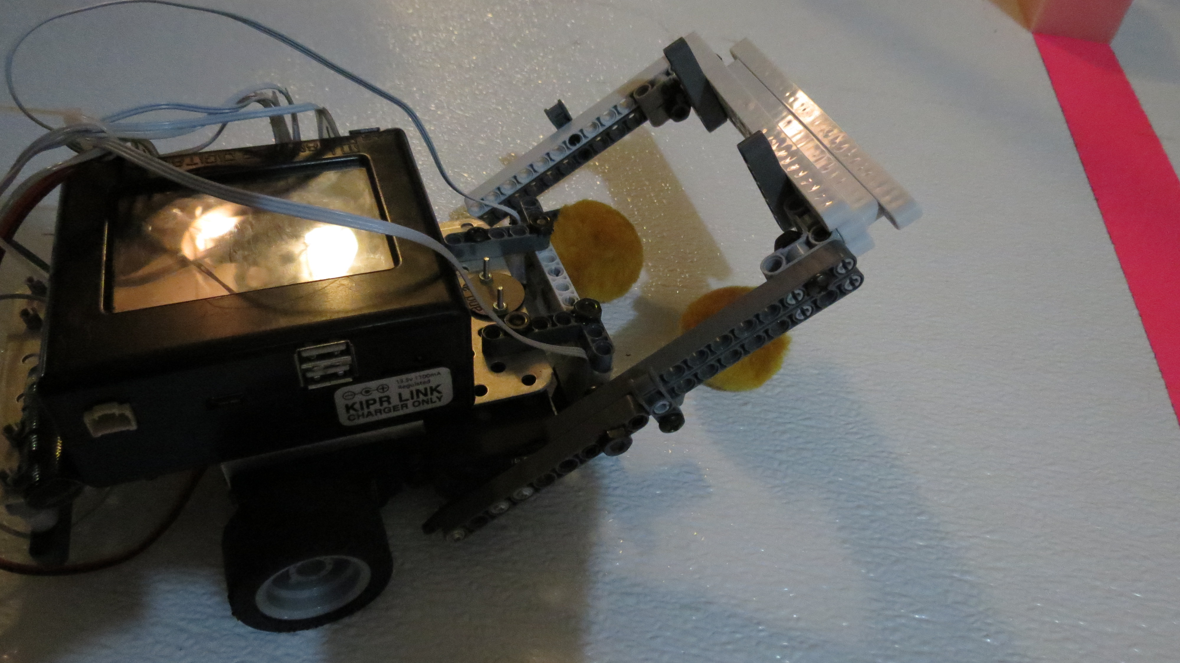

It also uses two reflectance sensors to detect the black divider and black tape. We had to use two reflectance sensors so that the Mickey Mouse bot would not see the black divider while it was looking for the black tape.

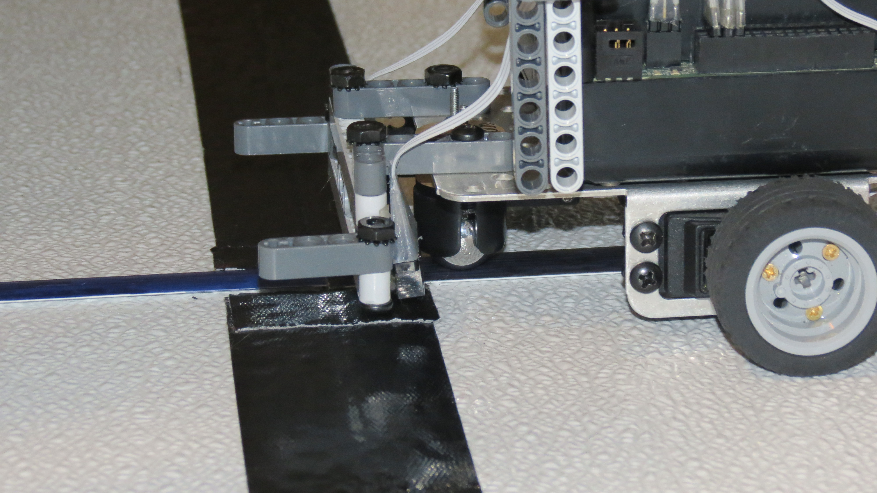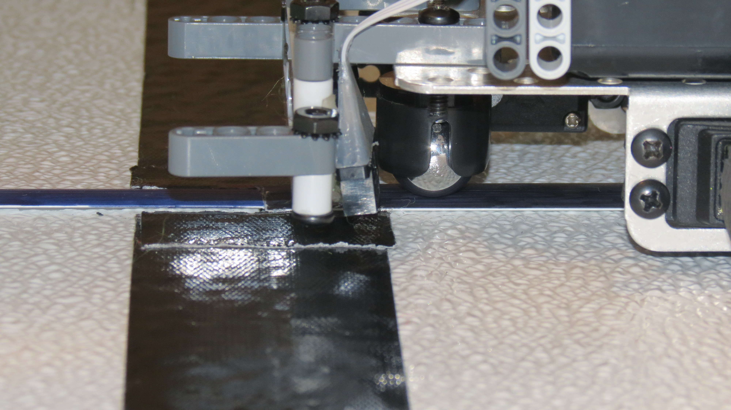

Snippet One: Finding divider.

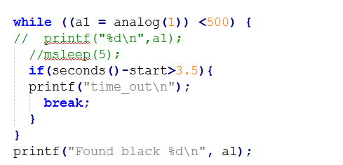

Snippet Two: Finding black tape.

Both reflectance sensors must see black.

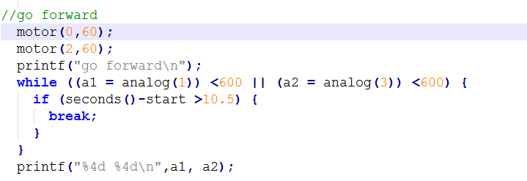

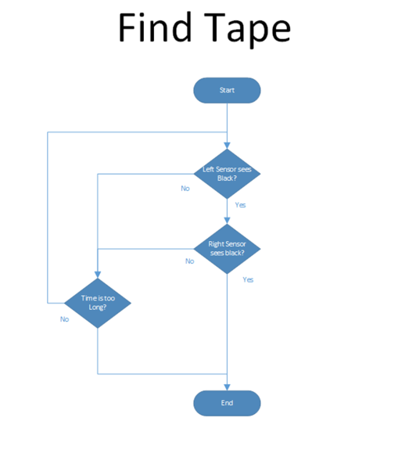

This is the flow chart of Program 2 🡪

Snippet Three: Follow black tape.

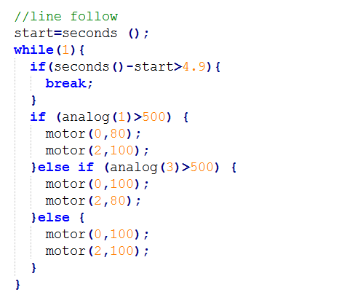

Graph of reflector sensor before it was balanced

Graph of reflector readings after the bot was balanced